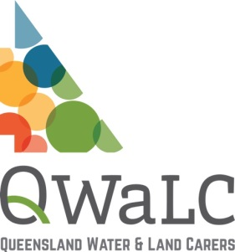
Work Health and Safety Induction
for community environmental groups
Volunteers and Employees
Template 003
VERSION 3-Q1 1.3.2016

A Work Health and Safety Induction is an essential component to inducting new staff, volunteers and committee members to XYZ Community Group. It provides a basic overview of health and safety aspects of working in your organisation. The WHS Induction will be stored along with Human Resources records. There are 3 main areas of workplace induction, including:

- Organisation and Job Introduction – staffing structure, reporting lines, job description and main tasks
- Terms and Conditions of Employment – pay, superannuation, leave and other entitlements
- WHS Induction

Employee / Volunteer name: |  | Position:
Date of commencement: |  | Person conducting induction:
Topic |  | Date Completed | Comments
Site tour
Explanation of the job description and work tasks
Copy of WHS Statement provided to employee
WHS responsibilities of the employer and the employee
Specific staff WHS responsibilities (if applicable)
WHS communication and consultation processes in place
Issue resolution processes and hazard reporting
Risk management procedures and template provided
Injury / incident reporting and investigation
Emergency procedures and location of emergency exits, assembly areas and emergency equipment
First Aid – location of facilities and identification of first aiders
Housekeeping – including waste disposal, keeping areas free of rubbish / clutter
Safety signage noted
How WHS information can be accessed
Training programs relating to WHS
Known relevant hazards to role
Relevant Safe Work Procedures / Job Safety Analysis documents and instructions
Manager / Supervisor: | Signature: |  |  | Date:
New employee: | Signature: |  |  | Date:

DISCLAIMER: The information contained in this publication is based on knowledge and understanding at the time of March 2016. However, because of advances in knowledge, users are reminded of the need to ensure that information upon which they rely is up to date and to check currency of the information with the appropriate officer of QWALC or the user’s independent advisor.

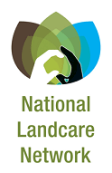
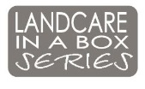
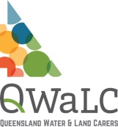
Landcare in a Box: an initiative of the National Landcare Network resourced by Landcare NSW and funded originally by NSW DPI.

