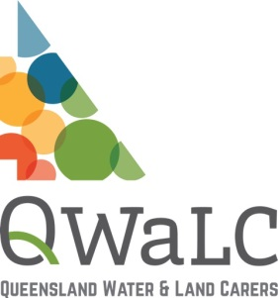
Copyright Policy
for community environmental groups
Template 017
VERSION 1-Q1 1.3.2016

Introduction | XYZ Community Group is responsible for managing its assets, including its intellectual assets, in a way that maximises their contribution to the goals of the organisation.  Subject to these responsibilities, XYZ Community Group is committed to the widest possible dissemination of its ideas, publications and findings where these may assist others.
Purpose | The purpose of this policy is to clarify the status of material subject to copyright used by the organisation, and to remove any possible misunderstandings about ownership of copyrights.
Policy:  Production of Copyright Material | Material created by staff of XYZ Community Group entirely on their personal time and not involving the use of the organisation’s facilities or materials shall be the property of the creator.  An individual's "personal time" shall mean time other than that for which they receive salary (in the case of staff) or perform assigned functions (in the case of volunteers).  Staff or volunteers who claim that material was made or created on personal time have the onus of demonstrating this proposition. Staff engaged in work during personal time where later confusion may possibly occur are encouraged to discuss this with their supervisors.  With the exception of material created on personal time, all materials that result from activities carried out at XYZ Community Group, or developed with the aid of XYZ Community Group 's facilities or staff, or developed through funds administered by XYZ Community Group, shall be the property of XYZ Community Group except by specific prior written agreement.  Works by independent contractors shall be owned in accordance with the contract under which the work was created. XYZ Community Group shall ensure that there is a written contract for work by an independent contractor specifying ownership.  Any dispute between XYZ Community Group and its staff or volunteers, or between staff or between volunteers, on issues of copyright ownership shall be determined by the organisation’s dispute resolution procedures.
Use of Copyright Material | Staff and volunteers of XYZ Community Group are required to observe all applicable copyright laws and regulations.  The Office Manager is required to institute procedures that will ensure  - that all uses of copyright materials are recorded, and that  - all compensable uses of copyright material are appropriately processed.
Copyright on XYZ Community Group Materials | All materials produced by or on behalf XYZ Community Group are copyright. Permission to reproduce such materials depends on the category into which they fall.  All materials produced by or on behalf of XYZ Community Group will be classified by the Office Manager into one of the following classes.  - Those materials that are copyright and that cannot be reproduced by any process other than for the purposes of and subject to the provisions of the Copyright Act and any licensing agreement between the user and XYZ Community Group.  - Those materials that are copyright and that may nonetheless be circulated and/or reproduced as long as any reproduction features specified credits and disclaimers.  - Those materials that are copyright and that may nonetheless be reproduced without conditions.  - Those materials that are not copyright.  The copyright policies of XYZ Community Group are binding on all staff, whether paid or voluntary. The copyright policies of XYZ Community Group, as amended from time to time, shall be deemed to be a part of the conditions of employment of every employee and shall be included in the orientation material given to every volunteer.
Responsibilities | It shall be the responsibility of the Executive Committee to ensure that these requirements of this policy are complied with.  These policy and procedures shall be reviewed every year by the Committee.
 |  | AUTHORISATION:
 |  | This version was approved on: | Click here to enter a date.
 |  | This version takes effect on: | Click here to enter a date.
 |  | Authorised by: | Insert name
 |  | Chairperson: | Insert name
 |  | Chairperson signature:
DISCLAIMER: The information contained in this publication is based on knowledge and understanding at the time of March 2016. However, because of advances in knowledge, users are reminded of the need to ensure that information upon which they rely is up to date and to check currency of the information with the appropriate officer of QWALC or the user’s independent advisor.

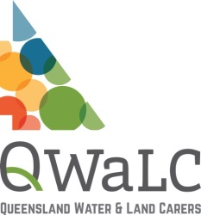
Landcare in a Box: an initiative of the National Landcare Network resourced by Landcare NSW and funded originally by NSW DPI.

